

**Polling District and Polling Place Review 2025**

**Monument Ward**

**Parliamentary Constituency:** Central and West

**(Proposed) Polling Districts:** R01, R02, R03, R04, R05

The Local Government Boundary Commission for England are an independent body accountable to Parliament. They are responsible for reviewing councils to make sure their patterns of internal wards are fair and sensible. Their reviews include at least two rounds of public consultation before they make recommendations for change.

The final recommendations were published on 7 January 2025, and the new arrangements apply to local elections from 2026.

As a result of changes to ward boundaries the Acting Returning Officer (ARO) is conducting a review of polling districts and polling places to ensure that they are suitable for the new ward boundaries.

For more information on the local government boundary review visit: <https://www.lgbce.org.uk/all-reviews/newcastle-upon-tyne>

This document provides details of the review, along with the initial recommendations and comments of the Acting Returning Officer (ARO). Also, the election rules require the ARO to decide how many polling stations are required for each polling station and the ARO must allocate electors to the polling stations in such manner as they think most convenient.

These recommendations will be open to all residents, stakeholders, and any interested parties. We shall be seeking representations from local disability groups on the accessibility and suitability of polling places. Any comments should be addressed in the first instance to pollingplaces@newcastle.gov.uk where they will be collated on behalf of the (Acting) Returning Officer.

We considered the following factors:

* **Identifying new polling places:** We will look for new polling places in areas where the existing provision is unsuitable or unavailable.
* **Feedback:** We will consider feedback received following recent elections, consultation from members of the public, elected members, and other stakeholders.
* **Accessibility:** We will try to ensure that every polling place is accessible to electors with disabilities.
* **Facilities**: We will make sure that all electors have such reasonable facilities for voting as are practicable in the circumstances.
* **Elector numbers:** We will try to comply with the Electoral Commission guidance on the maximum number of electors that should be allocated to a polling station which should not exceed 2,250.
* **Future housing developments**: We will consider the impact of proposed housing developments on polling station electorates.

**(Current) Monument Ward**

This map shows the current ward and polling district boundaries and the polling places.

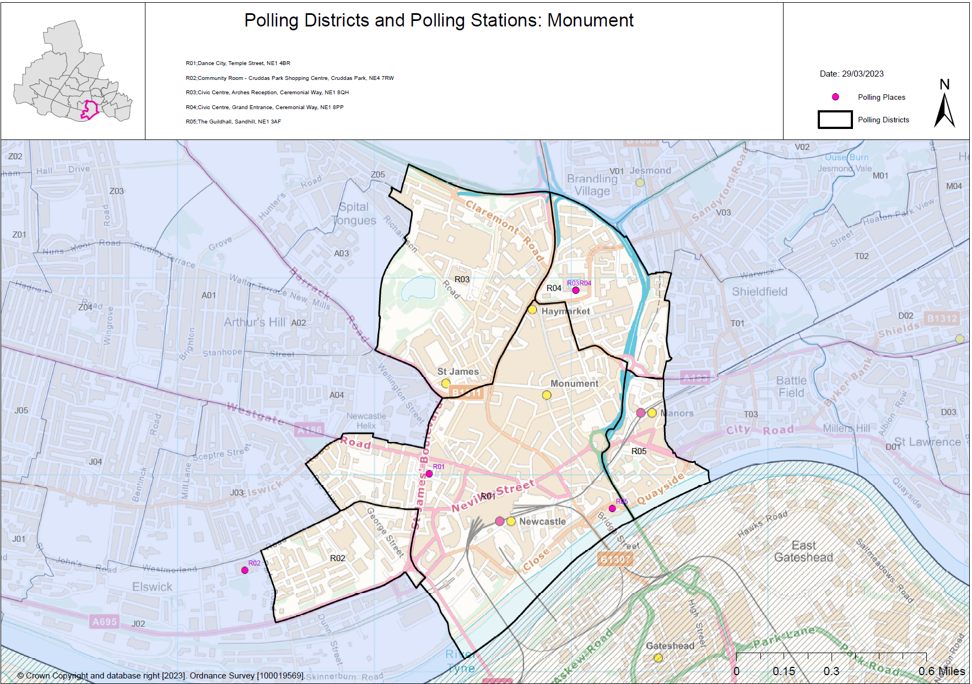

**(New)**

**Monument Ward**

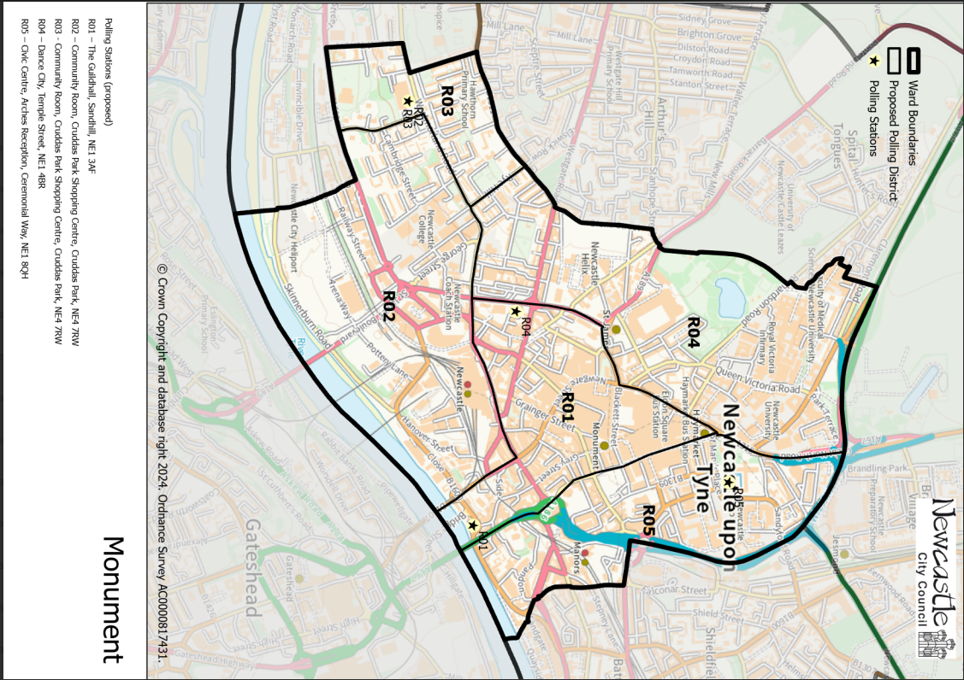

This map shows the new ward and the proposed polling districts and the proposed polling places.

* **R01** – The Guildhall, Sandhill, NE1 3AF
* **R02** – Community Room, Cruddas Park Shopping Centre, Cruddas Park, NE4 7RW
* **R03** – Community Room, Cruddas Park Shopping Centre, Cruddas Park, NE4 7RW
* **R04** – Dance City, Temple Street, NE1 4BR
* **R05** – Civic Centre, Arches Reception, Ceremonial Way, NE1 8QH

**Monument Ward**

**Polling District R01**

|  |  |  |
| --- | --- | --- |
| **Current Polling District** | | **Current Polling Place** |
| R01 (part of) | | Dance City, Temple Street, NE1 4BR |
|  | | |
| **Proposed Polling District** | **Predicted Polling Station Electorate** | **Proposed Polling Place** |
| R01 | 903 | The Guildhall, Sandhill, NE1 3AF |
|  | | |
| **Considerations and Proposals** | | |
| Part of current R01 forms the proposed R01 district.  Would lose properties to the south of Neville Street and Collingwood Street and the new boundary would run to Saint Nicholas Street. Would also lose properties to the east of Northumberland Street.  The proposal is to use The Guildhall for this district. | | |
|  | | |
| **Preliminary Consultation – Elected Members comments and feedback** | | |
| No comments received. | | |

**Monument Ward**

**Polling District R02**

|  |  |  |  |
| --- | --- | --- | --- |
| **Current Polling District** | | **Current Polling Place** | |
| R01 (part of)  R02 (full)  J02 (part of) | | Dance City, Temple Street, NE1 4BR  Community Room Cruddas Park, Cruddas Park Shopping Centre, Cruddas Park, NE4 7RW  Community Room Cruddas Park, Cruddas Park Shopping Centre, Cruddas Park, NE4 7RW | |
|  | | | |
| **Proposed Polling District** | **Predicted Polling Station Electorate** | | **Proposed Polling Place** |
| R02 | 949 | | Community Room Cruddas Park, Cruddas Park Shopping Centre, Cruddas Park, NE4 7RW |
|  | | | |
| **Considerations and Proposals** | | | |
| Part of current R01, all of current R02 and part of current J02 would merge to form the proposed R02 district. Gaining some properties from the current R01 district, south of Neville Street and west of Saint Nicholas Street and part of the current J02 district to the south, ending at Dunn Street.  Callerton Academy was contacted but the school is moving to Newbiggin Hall in the summer of 2025.  The community room at Cruddas Park Shopping Centre is in the proposed R03 district and is suggested as a double station for the proposed districts of R02 and R03. | | | |
|  | | | |
| **Preliminary Consultation – Elected Members comments and feedback** | | | |
| No comments received. | | | |

**Monument Ward**

**Polling District R03**

|  |  |  |
| --- | --- | --- |
| **Current Polling District** | | **Current Polling Place** |
| J02 (part of)  J03 (Part of) | | Community Room Cruddas Park, Cruddas Park Shopping Centre, Cruddas Park, NE4 7RW  West End Women and Girls Centre, Stephenson Building, 173 Elswick Road, NE4 6SQ |
|  | | |
| **Proposed Polling District** | **Predicted Polling Station Electorate** | **Proposed Polling Place** |
| R03 | 682 | Community Room Cruddas Park, Cruddas Park Shopping Centre, Cruddas Park, NE4 7RW |
|  | | |
| **Considerations and Proposals** | | |
| New district incorporating part of current J03 and part of current J02 to create the proposed R03 district.  The community room at Cruddas Park Shopping Centre is in the proposed R03 district and is suggested as a double station for the proposed districts of R02 and R03. | | |
|  | | |
| **Preliminary Consultation – Elected Members comments and feedback** | | |
| No comments received. | | |

**Monument Ward**

**Polling District R04**

|  |  |  |
| --- | --- | --- |
| **Current Polling District** | | **Current Polling Place** |
| R01 (part of)  R03 (full)  A03 (part of)  A04 (part of) | | Dance City, Temple Street, NE1 4BR  Civic Centre, Arches Reception, Ceremonial Way, NE1 8QH  Spital Tongues Community Centre, Morpeth Street, NE2 4AS  Westgate Baptist Church, 366 Westgate Road, NE4 6NX |
|  | | |
| **Proposed Polling District** | **Predicted Polling Station Electorate** | **Proposed Polling Place** |
| R04 | 1222 | Dance City, Temple Street, NE1 4BR |
|  | | |
| **Considerations and Proposals** | | |
| Very small part of current A03 (by Richardson Road), part of current A04, part of current R01 and all of current R03 merge to form the proposed R04.  Dance City is the suggested polling station for this district. It is located within the proposed R01 district. | | |
|  | | |
| **Preliminary Consultation – Elected Members comments and feedback** | | |
| No comments received. | | |

**Monument Ward**

**Polling District R05**

|  |  |  |
| --- | --- | --- |
| **Current Polling District** | | **Current Polling Place** |
| R01 (part of)  R04 (part of)  R05 (full) | | Dance City, Temple Street, NE1 4BR  Civic Centre, Grand Entrance, Ceremonial Way, NE1 8QH  The Guildhall, Sandhill, NE1 3AF |
|  | | |
| **Proposed Polling District** | **Predicted Polling Station Electorate** | **Proposed Polling Place** |
| R05 | 1006 | Civic Centre, Arches Reception, Ceremonial Way, NE1 8QH |
|  | | |
| **Considerations and Proposals** | | |
| Part of the current R01, part of current R04 and all of the current R05 merge to form the proposed R05 district.  Taking on part of the current R01 to Northumberland Street in the west and along Pilgrim Street, to join the boundary with the current R05 district.    The Civic Centre is located within the proposed R05 district. | | |
|  | | |
| **Preliminary Consultation – Elected Members comments and feedback** | | |
| No comments received. | | |

THIS PAGE IS INTENTIONALLY BLANK